
SECJ2203: Software Engineering
System Documentation (SD)

KKK Online System
Version 1.1

06/12/2024

Faculty of Computing

Prepared by:
Chua Jia Lin
Goe Jie Ying
Lam Yoke Yu
Tan Yi Ya
Teh Ru Qian

Revision Page

Overview
The current version of the KKK Online System is to improve cooperative procedures such as member registration, loan application management, administrative tasks, approval tracking and financial reporting. By digitising manual processes and enabling online registration, loan applications and approval tracking, it improves accessibility and efficiency. Board members look over and approve applications, while administrators manage data and policies.

Target Audience
The System Documentation is designed for system developers, administrators and technical support teams that are responsible for implementing, maintaining and troubleshooting the KKK online system. It is also created for board members and other stakeholders who require a high-level understanding of the system’s operations and procedures in order for management and decision-making.

Project Team Members
Member Name | Role | Task | Status
Tan Yi Ya | Project manager | - Specify design constraints  - Define performance and other requirements | Complete
Chua Jia Lin | System analyst | - Create user story for KKK admin  - Draw sequence diagram  - Draw activity diagram | Complete
Goe Jie Ying | System designer | - Create user story for apply membership  - Draw sequence diagram  - Draw activity diagram | Complete
Lam Yoke Yu | System developer | - Document launch phase  - Draw state diagram  - Draw class diagram  - Draw use case diagram | Complete
Teh Ru Qian | System testing | - Create user story for apply loan  - Draw sequence diagram  - Draw activity diagram | Complete

Version Control History

Version | Primary Author | Description of Version | Date Completed
1.0 | Chua Jia Lin  Goe Jie Ying  Lam Yoke Yu  Tan Yi Ya  Teh Ru Qian | Completed all sections in the system documentation | 30/11/2024
1.1 | Chua Jia Lin  Goe Jie Ying  Lam Yoke Yu  Tan Yi Ya  Teh Ru Qian | Edited user diagram and class diagram | 06/12/2024

Table of Contents
Revision Page 2
a. Overview 2
b. Target Audience 2
c. Project Team Members 2
d. Version Control History 3
Table of Contents 1
1. Introduction 3
1.1 Purpose 3
1.2 Scope 3
1.3 Definitions, Acronyms and Abbreviation 4
1.4 References 4
1.5 Overview 4
2. Specific Requirements 5
2.1 Persona 6
2.1.1 Persona 1: KADA Employee (New User) 6
2.1.2 Persona 2: KADA Employee (Existing User) 6
2.1.3 Persona 3: KKK Admin 6
2.2 System Features 7
2.2.1 Use Case Diagram 7
2.2.2 Domain Model: Class Diagram 14
2.2.3 State Diagram 20
2.3 Launch Phase 22
2.4 User Story Details 22
2.4.1 US01 User Story Apply Membership 22
2.4.2 US02 User Story Update User Profile 24
2.4.3 US03 User Story View Financial Status 26
2.4.4 US04 User Story Apply for a Loan 28
2.4.5 US05 User Story View Loan Application Status 30
2.4.6 US06 User Story KKK Admin Login to System 32
2.4.7 US07 User Story KKK Admin View List 34
2.4.8 US08 User Story KKK Admin Approve New Member Application 36
2.4.9 US09 User Story KKK Admin Approve Loan Application 38
2.4.10 US10 User Story KKK Admin Generate Reports 40
2.4.11 US11 User Story KKK Admin Record Transactions 42
2.4.12 US12 User Story KKK Admin Update Policies 44
2.4.13 US13 User Story KKK Admin Update Banners 46
2.5 Performance and Other Requirements 48
2.5.1 Software System Attributes 48
2.5.2 Performance 49
2.5.3 Other Requirements 49
2.6 Design Constraints 49
2.6.1 Security constraints 49
2.6.2 Safety constraints 49
2.6.3 Business Rule 50

Introduction
This section provides an overview of the System Documentation (SD), including the introduction of the KKK Online System and its requirements.

Purpose
The purpose of this System Document is to describe the KKK Online System. This document describes and defines the user interface, functions, performance, security and quality requirements for developing the system.

This document is intended for the development team, including but not limited to designers, developers, project managers, end-user, test and managers.

Scope
The software product to be produced is KKK Online System. The system functions as an online medium to handle various actions such as member registration, service tracking, administrative management and data reporting. The KKK Online System includes functionality of:

- New Member Registration
The new member can apply for cooperative membership using online application form, which reduces paperwork and enables remote access.

- Loan Application Management
The loan application can be submitted through the online system, allowing applicants to track their application status online.

- Administrator Controls
Administrators manage member data, prepare applications for board review, and update system policy.

- Approval Process
The system allows applications to be printed for board meetings, where directors review and make approval decisions that administrators then enter into the system.

- Financial Reporting
The system generates monthly and annual reports from stored data, aiding the cooperative in evaluating its financial and operational performance from time to time.

The system does not include the following functionality:
- Increasing number of share by member
- Transaction into or out of user account
- Generate monthly profit and loss report

The KKK Online System should ease the process of applying for membership, loan and other relevant processes by taking away the burden of travelling physically to carry out the action. By digitising previously manual processes, the system aims to enhance data security, improve efficiency and accessibility for all stakeholders, including new applicants, members, administrators, and board members. The system should have different functions based on user roles, and support multiple end devices such as desktop and mobile platforms, to allow accessibility across various devices.

Definitions, Acronyms and Abbreviation
This section provides the definitions of all terms, acronyms, and abbreviations required to interpret this System Documentation.
KADA | Lembaga Kemajuan Pertanian Kemubu
KKK | Koperasi Kakitangan Daerah Kelantan Berhad.
SD | System Documentation
ISO/IEC | International Organization for Standardization/International Electrotechnical Commission
IEEE | Institute of Electrical and Electronics Engineers
TLS | Transport Layer Security
WPA | Wi-Fi Protected Access
UTC | Coordinated Universal Time

References
[1] Sommerville, I. (2016). “Software Engineering”, 10th Edition, US: Pearson.

[2］ “Portal Lembaga Kemajuan Pertanian Kemubu | KADA KEMUBU.” http://www.kada.gov.my/

[3］ R. Wherrity, “Waterfall Project Management: Comprehensive Guide For Success,” Brand, https://www.clearpointstrategy.com/blog/waterfall-project-management

Overview
The remainder of this SD includes the following:

- A description of Persona that specifies the characteristics and needs of the intended user of the KKK system in general.
- System features with supporting diagrams to push the understanding further, for example use case diagram, class diagram and state diagram.
- Product backlog that plans each sprint according to the use case diagram, assigning each team member.
- A detailed description of the user story for each use case, simulating different scenarios of user story, specifying the user needs further with supporting diagrams.
- Non-functional requirements that declare the characteristics or qualities of the system, to describe the behaviour and the operation norm of the system.
- Design constraints defined by the stakeholders.

This SD follows ISO/IEC/IEEE 29148 standard guidelines to ensure clarity, consistency, and usability.

Specific Requirements
This section outlines the software requirements in detail in order to guide the process of design, development, and testing. By describing all required inputs, outputs, and functionality in specifics, it ensures that the system satisfies the needs of users and stakeholders.

Persona
This section introduces the target users of the system, focusing on their characteristics and needs. Understanding the personas helps ensure that the system is appropriate for its target audience.

Persona 1: KADA Employee (New User)
User Need: A KADA Employee needs to become a new member of the KKK.
User Stories:
- As a KADA employee, I want to register myself as a new member of the cooperation so that I can access the benefits provided by the corporation
- As a KADA employee, I want to complete my personal information and the details of my family.
- As a KADA employee, I want to log in to the KKK system and check my personal information to ensure its accuracy.

Persona 2: KKK member (Existing User)
User Need: A KKK member needs a way to apply for a loan easily.
User Stories
- As a KKK member, I want to apply for a loan to receive financial assistance.
- As a KKK member, I want to update my details and select a loan amount so that my application is accurate.
- As a KKK member, I want to upload necessary documents to complete my application.
- As a KKK member, I want to check my loan status so I know if it is approved.
- As a KKK member, I want to see my loan information and repayment amount after applying so that I can plan my payments.

Persona 3: KKK Admin
User Need: KKK admins requires a system to ease the application approval process, policy updating process, reporting and record transaction process.
User Stories:
- As a KKK admin, I want to login to the system so that I can access the features of the system.
- As a KKK admin, I want to view applicant lists for new members and loan applications so that I can proceed with the approval process.
- As a KKK admin, I want to approve new member applications so that I can check whether the applicant meets the requirements to become a member of the cooperative.
- As a KKK admin, I want to approve loan applications so that I can check whether the applicant meets the requirements to make a loan .
- As a KKK admin, I want to generate reports so that future decisions can be made for the cooperative.
- As a KKK admin, I want to record transactions made by members so that transactions can be reflected in the member profile.
- As a KKK admin, I want to update policies so that the cooperative business rules such as minimum share capital requirements for loan application and the loan interest rate can be known by members.
- As a KKK admin, I want to update banners on the system so that members will know the announcement from the cooperative.

System Features
KKK Online System is a web-based software. The system provided a means for the KKK members and staff to better manage the member application and loan application. It also has other features such as updating user profile, viewing financial status, generating reports, recording transactions and updating policies and banners.

Use Case Diagram
The system features are illustrated in Figure 1.1 below. The detailed description of each module and functions is tabulated in Table 1.1.
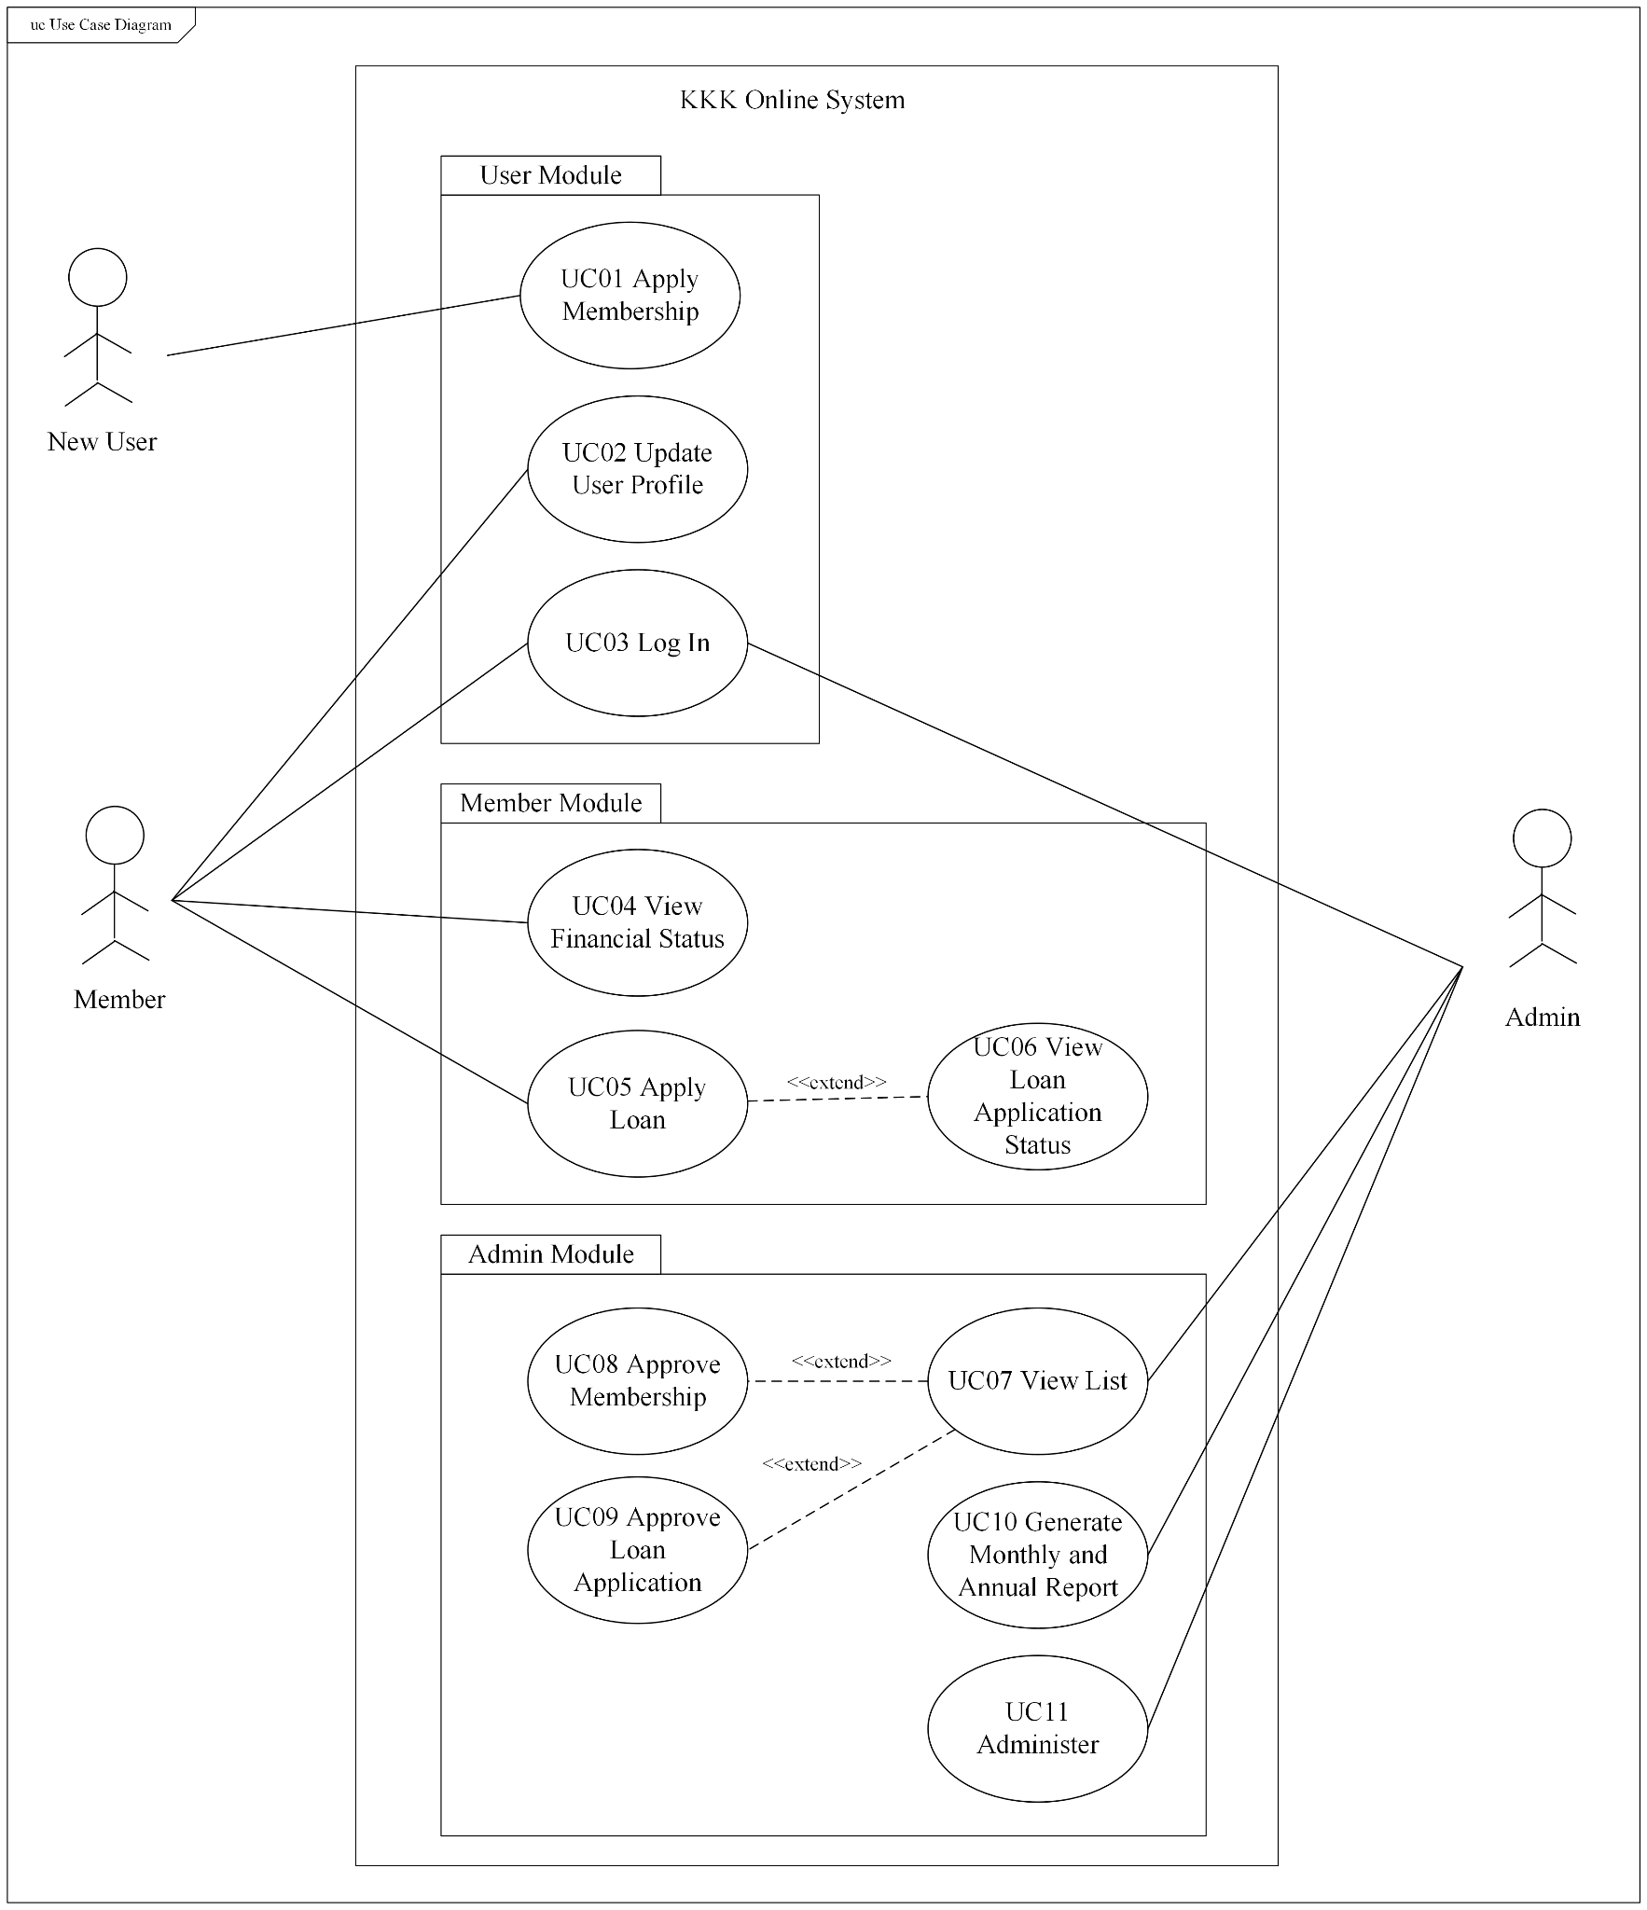
Figure 1.1 Use Case Diagram for KKK Online System

Table 1.1: Description of Module and Functions for KKK Online System
Use Case | Function | Description
UC01 | Apply Membership | The employees in KADA can apply to be a member of the KKK cooperative by filling in the online form and upload any required documents.
UC02 | Update User Profile | The cooperative members can update their user personal information, and the family and inheritor information.
UC03 | Log In | The cooperative member and the administrator can log in the system by using the correct login credentials. The members will then be directed to the member’s page and the administrator will be directed to the administrator’s page.
UC04 | View Financial Status | Upon log in to the system, the cooperative member would be able to view their financial status including the share information (Maklumat Saham Ahli) and the loan information (Maklumat Pinjaman Ahli).
UC05 | Apply Loan | The cooperative members can apply for financing services from the cooperative by filling in the online form and upload any required documents.
UC06 | View Loan Application Status | Upon the loan application submission, they would be able to see their application status through the system.
UC07 | View List | The administrator would be able to view the list of membership and loan applications as well as the existing members and borrowers.
UC08 | Approve Membership | The admin would be able to update the status of the membership application.
UC09 | Approve Loan Application | The admin would be able to update the status of the loan application.
UC10 | Generate Monthly and Annual Report | The admin can generate monthly and annual reports that summarise the financial and membership information.
UC11 | Administer | After a transaction settled between the stakeholders, the admin would update the transaction in the system to reflect the transaction in the member profile. This includes updating the amount of share capital, funds, contributions and loans.  Besides, the administrator would be able to update policies such as the minimum membership, minimum share capital requirement for loan application, loan interest rate, maximum loan repayment duration and maximum financing amount.  The administrator can also update the website banner. This ensures the sustainability of the system.

Functional Requirement of Each Use Case
UC01 Apply Membership
REQ-1: The system shall validate the user input.
- Email address format
- Identity card number format
- Phone number format

REQ-2: The system shall display error messages for invalid input
- Missing required fields
- Incorrect input format

REQ-3: The system shall send an email to the user and the administrator upon the submission of the application.

REQ-4: The system shall ensure that all data is stored securely and comply with relevant data protection regulations.

REQ-5: The system shall display a confirmation message to the user after successfully updating the database.

UC02 Update User Profile
* REQ-1, REQ-2, REQ-4 and REQ-5 from the UC01 Apply Membership are also applicable to UC02 Update User Profile.

REQ-1: The system shall validate the user input.
- Email address format
- Identity card number format
- Phone number format

REQ-2: The system shall display error messages for invalid input
- Missing required fields
- Incorrect input format

REQ-4: The system shall ensure that all data is stored securely and comply with relevant data protection regulations.

REQ-5: The system shall display a confirmation message to the user after successfully updating the database.

REQ-6: The system shall retrieve all relevant user information.
- Member personal information

UC03 Log In
REQ-7: Users should be able to login using valid login credentials.

UC04 View Financial Status
* REQ-6 from the UC01 Apply Membership are also applicable to UC05 Apply Loan.

REQ-6: The system shall retrieve all relevant user information.
- Financial status of the user

UC05 Apply Loan
* REQ-1, REQ-2, REQ-3, REQ-4 and REQ-5 from the UC01 Apply Membership are also applicable to UC05 Apply Loan.

REQ-1: The system shall validate the user input.
- Email address format
- Identity card number format
- Phone number format

REQ-2: The system shall display error messages for invalid input
- Missing required fields
- Incorrect input format

REQ-3: The system shall send an email to the user and the administrator upon the submission of the application.

REQ-4: The system shall ensure that all data is stored securely and comply with relevant data protection regulations.

REQ-5: The system shall display a confirmation message to the user after successfully updating the database.

* REQ-6 from the UC02 Update User Profile are also applicable to UC05 Apply Loan.
REQ-6: The system shall retrieve and auto-fill relevant user information in the "Butir-Butir Peribadi Pemohon" section based on the user's profile, so that the user does not need to re-enter the same information.

UC07 View List
* REQ-3 and REQ-5 from the UC01 Apply Membership are also applicable to UC07 View List.
REQ-3: The system shall send an email notification to the applicant regarding the updated application status after the administrator makes the selection.

REQ-5: The system shall display a confirmation message to the user after successfully updating the database.

* REQ-6 from the UC02 Update User Profile are also applicable to UC07 View List.
REQ-6: The system shall retrieve all relevant information.
- List of member application
- List of loan application
- List of existing members
- List of current debtors

REQ-8: The system shall maintain an audit log of status changes made by the administrator, including timestamps and admin ID.

UC10 Generate Monthly and Annual Report
* REQ-6 and REQ-8 from the UC08 View List are also applicable to UC10 Generate Monthly and Annual Report.
REQ-6: The system shall retrieve all relevant information.
- List of member application
- List of loan application
- List of existing members
- List of current debtors
- Transaction Records

REQ-8: The system shall maintain an audit log of retrieval made by the administrator, including timestamps and admin ID.

REQ-9: The system shall generate and display the report for the selected month or year upon selection by the administrator.

REQ-10: The system shall allow the administrator to export the report in various formats (e.g., PDF, Excel).

UC11 Administer
* REQ-1, REQ-2, REQ-4 and REQ-5 from the UC01 Apply Membership are also applicable to UC11 Administer.
REQ-1: The system shall validate the user input.
- Member Number
- Transaction Amount
- Validate the input fields for policies
- Ensure that the amount does not exceed the limit or form a negative record
- Integers
- Doubles
- File type
- Size and dimension of uploaded image

REQ-2: The system shall display error messages for invalid input
- Missing required fields
- Incorrect input format

REQ-4: The system shall ensure that all data is stored securely and comply with relevant data protection regulations.

REQ-5: The system shall display a confirmation message to the user after successfully updating the database.

* REQ-6 and REQ-8 from the UC08 View List are also applicable to UC11 Administer.
REQ-6: The system shall retrieve all relevant information.
- Members
- Financial Status
- Existing policies
- Existing banners

REQ-8: The system shall maintain an audit log of status changes made by the administrator, including timestamps and admin ID.

REQ-11: The system shall update the application and related databases with the new policy upon submission by the administrator.

Domain Model: Class Diagram
The domain model of the KKK Online System is illustrated in Figure 1.2 below.
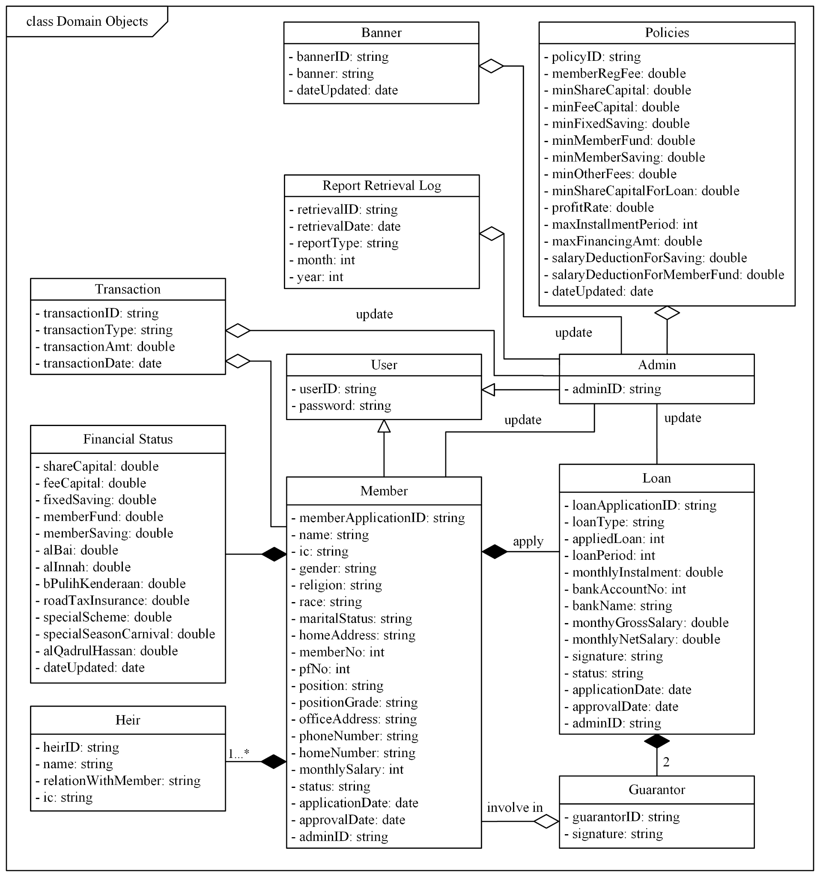
Figure 1.2: Domain Model for KKK Online System

User Class
Represents all users that use the system. The information in this class will act as login credentials to the system.

- userID: A unique identifier for user
- password: Password to login to the system

Member Class
Represents a person registered in the system as a member. As a user applies for a member, an object of the member is created.

- memberApplicationID: A unique identifier for membership application.
- name: Name of the member.
- ic: Identity card (MyKad) number of the member.
- gender: Gender of the member. This attribute is an enumeration with the values Male (Lelaki) and Female (Perempuan).
- religion: Religion of the member. This attribute is an enumeration with the values Islam, Buddhism (Buddha), Hinduism (Hindu), Christianity (Kristian) and Others (Lain-lain).
- race: Race of the members. This attribute is an enumeration with the values Malay (Melayu), Chinese (Cina), Indian (India) and Others (Lain-lain).
- maritalStatus: Marital status of the member.
- homeAddress: Address of the member.
- memberNo: Member number of the member. The member number would be available as the application is approved.
- pfNo: PF number of the member.
- position: Position held by the member.
- positionGrade: Position grade of the member.
- officeAddress: Address of the member on duty.
- phoneNumber: Phone number of the member.
- homeNumber: Home number of the member.
- monthlySalary: Monthly salary of the member with the currency of RM.
- status: Application status of the member. This attribute is an enumeration with the values Processing (Sedang Diproses), Rejected (Ditolak) and Accepted (Dilulus).
- applicationDate: Date when the application is submitted.
- approvalDate: Date when the application is approved..
- adminID: A unique identifier for the admin.

The Member class is inherited from the User class. A member whose status is accepted would be eligible to apply for a loan.

Heir Class
Represents an heir (pewaris) for a member.

- heirID: A unique identifier for the heir.
- name: Name of the heir.
- relationshipWithMember: Relationship of the heir with associated the member.
- ic: Identity card (MyKad) number of the heir.

The Heir class is a composition of the Member class. The relation is one to many relation, where a member can have one or more heirs.

Financial Status Class
Represents the financial status of the associated member.

- shareCapital: Share capital (Modah Syer) of the associated member with the currency of RM.
- feeCapital: Fee Capital (Modal Yuran) of the associated member with the currency of RM.
- fixedSaving: Fixes Saving or Fixed Deposit (Simpanan Tetap) of the associated member with the currency of RM.
- memberFund: Member Fund (Tabung Anggota) of the associated member with the currency of RM.
- memberSaving: Member Saving (Simpanan Anggota) of the associated member with the currency of RM.
- alBai: The loan amount in the Al-Bai category for the associated member in RM.
- alInnah: The loan amount in the Al-Innah category for the associated member in RM.
- bPulihKenderaan: The loan amount in the Baik Pulih Kenderaan category for the associated member in RM.
- roadTaxInsurance: The loan amount in the Road Tax & Insurance category for the associated member in RM.
- specialScheme: The loan amount in the Special Scheme (Khas) category for the associated member in RM.
- specialSeasonCarnival: The loan amount in the Special Season Carnival (Karnival Musim Istimewa) category for the associated member in RM.
- alQadrulHassan: The loan amount in the Al-Qadrul Hassan category for the associated member in RM.
- dateUpdated: The last date of the financial status is updated. The update is made by the admin and detailed in the Transaction class.

The Financial Status class is a composition of the Member class. The relationship is a one to one relationship.

Loan Class
Represents the loan application applied by the associated member.

- loanApplicationID: A unique identifier for the loan application.
- loanType: The type of loan applied by the member. This attribute is an enumeration with the values Al-Bai, Al-Innah, Baik Pulih Kenderaan, Road Tax and Insurance, Special Scheme (Khas), Special Season Carnival (Karnival Musim Istimewa) and Al-Qadrul Hassan.
- appliedLoan: The amount of loan applied by the member in RM.
- loanPeriod: The instalment period of the applied loan.
- monthlyInstalment: The monthly instalment amount of the applied loan in RM.
- bankAccountNo: The bank account number of the applicant.
- bankName: The bank associated with the bank account number provided.
- monthyGrossSalary: The monthly gross salary of the applicant in RM.
- monthlyNetSalary: The monthly net salary of the applicant in RM.
- signature: The reference to the uploaded acknowledgement form with the signature of the applicant’s employer.
- status: Application status of the member. This attribute is an enumeration with the values Processing (Sedang Diproses), Rejected (Ditolak) and Accepted (Diterima).
- applicationDate: Date when the application is submitted.
- approvalDate: Date when the application is approved..
- adminID: A unique identifier for the admin.

A member of the cooperative fulfilling certain criterias would be able to apply for loans.

Guarantor Class
Represents a guarantor for the loan application.

- guarantorID: A unique identifier for the guarantor application.
- memberNo: The member number of the guarantor.
- signature: The reference to the uploaded acknowledgement form with the signature of the applicant’s employer.

The Guarantor class is a composition of the Loan Application class, where there must be two guarantors for each application. At the same time. The Guarantor class is associated with the Member class, where the guarantor has to be a member.

Admin Class
Represents a person registered in the system as an admin.
- adminID: A unique identifier for the admin.

The Admin class is inherited from the User class. The adminID would be the same as the userID. An admin would be able to update the status of the Member class, Loan class, Policies class and Transaction class. Besides, the updates would be logged into Policy Update Log class, Application Approval Log class, Banner Update Log class, Report Retrieval Log class.

Report Retrieval Log Class
The class records the details of report retrieval. This serves as a record for tracking and auditing purposes.

- retrievalID: A unique identifier for the report.
- retrievalDate: Date when the report is retrieved.
- reportType: The type of report. This attribute is an enumeration with the values Monthly (Bulanan) and Annually (Tahunan).
- month: Month of the report. The value ranged from 0 to 12. If this is an annual report, it will be represented by 0.
- year: Year of the report.

This class is associated with the Admin class and Report class. The aggregation between the Admin class and the Report Retrieval Log class specifies the admin who retrieves the report. While the aggregation between the Report class specifies the report that is retrieved.

Banner Update Log Class
The class records the details of website banner updates. This serves as a record for tracking purposes.

- bannerID: A unique identifier for the uploaded banner.
- banner: The reference to the uploaded banner.
- dateUpdated: Date when the banner is updated.

This class is associated with the Admin class. The aggregation between the Admin class and the Banner Update Log class specifies the admin who updated the banner.

Policies Class
Represents the policies that validates the input for the system.

- policyID: A unique identifier for the policy.
- memberRegFee: The registration fee (Fee Masuk) in RM, that should be paid by the applicant once approved to be a member.
- minShareCapital: Minimum share capital (Modah Syer Minimum) for a member in RM.
- minFeeCapital: Minimum fee capital (Modal Yuran Minimum) in RM.
- minFixedSaving: Minimum fixed saving or fixed deposit (Wang deposit Anggota Minimum) in RM.
- minMemberFund: Minimum member fund contribution (Sumbangan Tabung Kebajikan Minimum) in RM.
- minMemberSaving: Minimum member savings (Simpanan Tetap Minimum) in RM.
- minOtherFees: Minimum amount of other fee (Lain-lain) in RM.
- minShareCapitalForLoan: Minimum share capital (Modah Syer Minimum) for a member in RM.
- profitRate: Profit rate or interest rate (Kadar Keuntungan) for financing services in percentage.
- maxInstalmentPeriod: Maximum loan instalment period (Tempoh Ansuran Maksima) in months.
- maxFinancingAmt: Maximum financing amount (Jumlah Pembiayaan Maksima) in RM.
- salaryDeductionForSaving: Monthly Salary Deduction Amount for Saving (Potongan Gaji Bulanan untuk Simpanan Tetap) in RM.
- salaryDeductionForMemberFund: Monthly Salary Deduction Amount for Member Fund (Potongan Gaji Bulanan untuk Tabung Kebajikan) in RM.
- dateUpdated: Date when the policy is updated.

Transaction Class
Represent the transaction record. This class also serves as a record for tracking and auditing purposes.

- transactionID: A unique identifier for the transaction record.
- transactionType: The type of transaction made. This attribute is an enumeration with the values Share Capital (Modah Syer), Fee Capital (Modal Fee), Fixed Saving (Simpanan Tetap), memberFund (Tabung Anggota), memberSaving (Simpanan Anggota), Al-Bai, Al-Innah, Baik Pulih Kenderaan, Road Tax and Insurance, Special Scheme (Khas), Special Season Carnival (Karnival Musim Istimewa) and Al-Qadrul Hassan.
- transactionAmt: The amount of the transaction in RM.
- transactionDate: Date when the transaction is updated.

This class is associated with the Admin class and the Member class. The aggregation with the Admin class specifies the admin who updated the transaction. The aggregation with the Member class specifies the member whose financial status is being updated.

State Diagram
The state diagram shows the states and transitions of an object throughout the system. The Member class and the Loan class would require a state diagram that shows the transition of application status.

Figure 1.3 shows the state diagram for the Member class. Once the user submits the application, the application will be in Processing state. After the meeting with the Board of Directors, the result of the application will be updated to either Approve state or Rejected state. As the application is approved, the applicant will be a member of the cooperative.
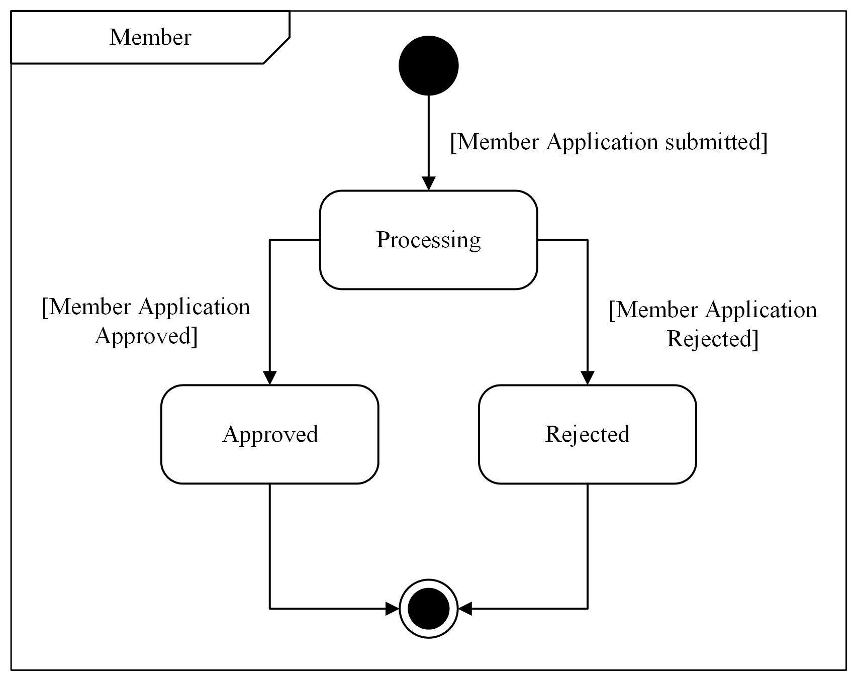
Figure 1.3: State Machine Diagram for Member Class

Figure 1.4 shows the state diagram for the Loan class. Once the user submits the application, the application will be in Processing state. After the meeting with the Board of Directors, the result of the application will be updated to either Approve state or Rejected state.
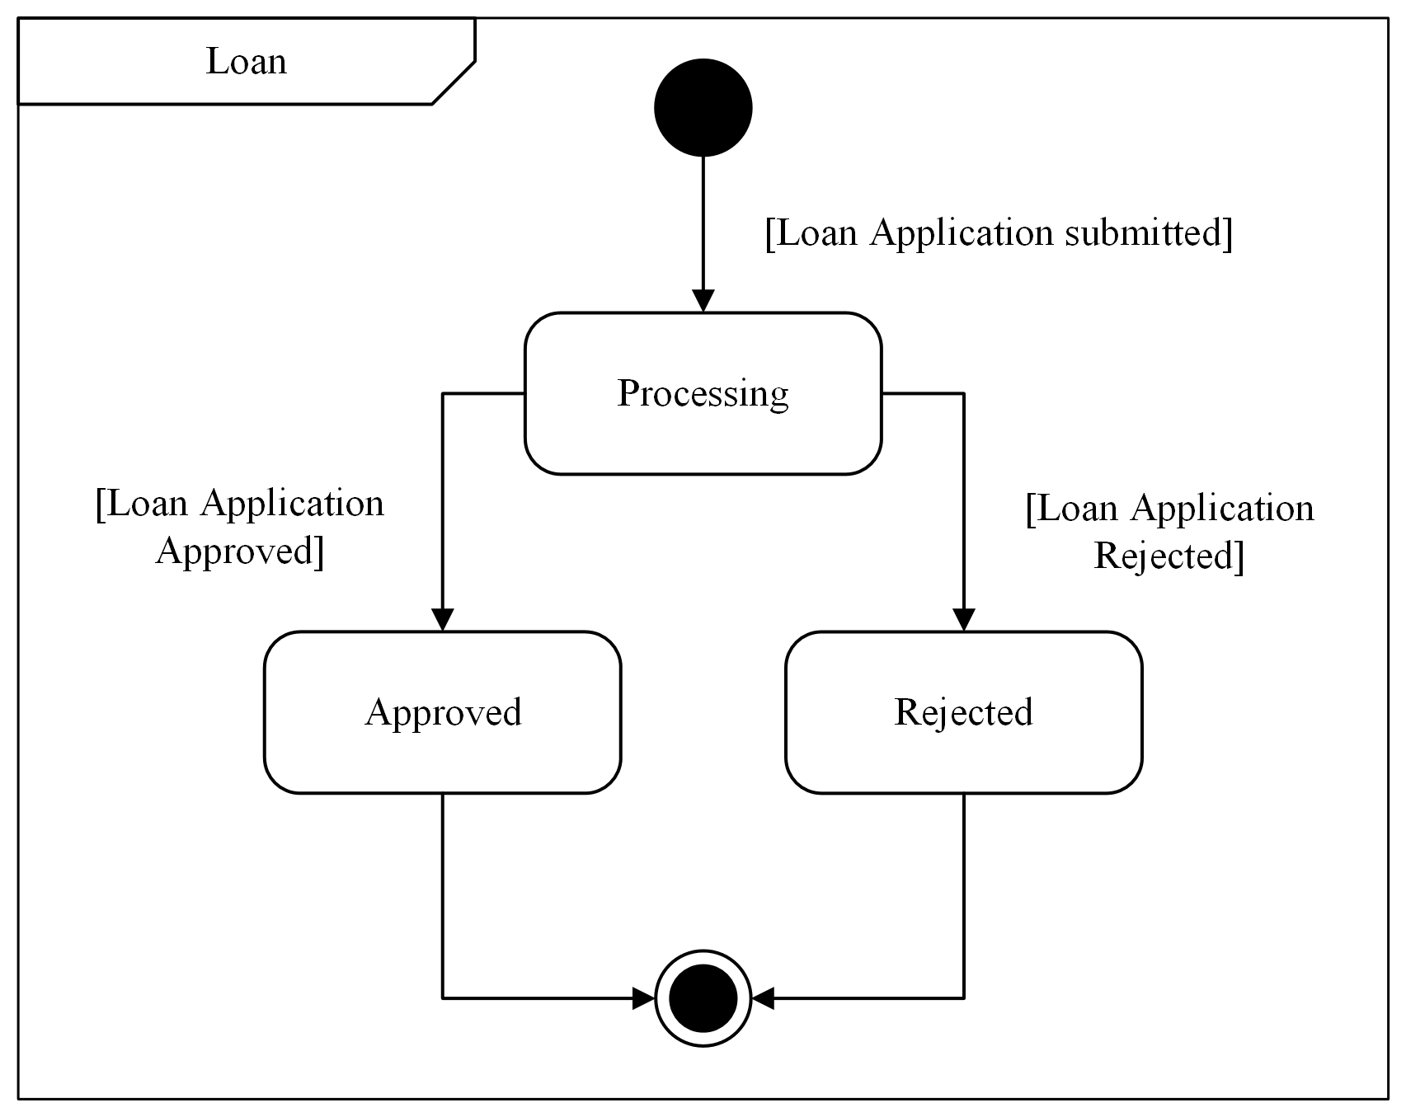
Figure 1.4: State Machine Diagram for Member Class

Launch Phase
The product backlog lists the parts and modules for the project according to the priorities. Table 1.2 shows the product backlog for the KKK Online System.

Table 1.2 Product Backlog for the KKK Online System
Sprint | Use Case Involved | Team Members Assigned
Sprint 1  User Module | UC01 Apply Membership (US01)  UC03 Log In (US06) | Tan Yi Ya
 | UC02 Update User Profile (US02) | Chua Jia Lin
Sprint 2  Member Module | UC04 View Financial Status (US03) | Chua Jia Lin
 | UC05 Apply Loan (US04)  UC06 View Loan Application Status (US05) | Teh Ru Qian
Sprint 3  Admin Module | UC07 View List (US07)  UC08 Approve Membership (US08)  UC09 Approve Loan Application (US09) | Goe Jie Ying
Sprint 4  Admin Module | UC10 Generate Monthly and Annual Report (US10) | Teh Ru Qian
 | UC11 Record Transaction (US11)  UC12 Update Policies (US12)  UC13 Update Banner (US13) | Lam Yoke Yu

User Story Details
This section outlines the user's goals and expectations for the system, focusing on the required actions. It defines the user story's scope, flow of events, sequence diagram, and activity diagram to ensure the system effectively meets the user’s needs.

US01 User Story Apply Membership
Table 2.1 shows the user story description, followed by the sequence diagram in Figure 2.1 and the activity diagram in Figure 2.2.

Table 2.1: User Story Description for Apply Membership
User story: Apply Membership
ID: US01
User Story Description:
As a KADA employee
I want to register myself as a new member of the cooperative
So that I can access the benefits provided by the corporative
Flow of events:
- The employee accesses the system through the website.
- The employee chooses to register as a member.
- The employee inputs all the required details.
- The system presents the “Akuan Kebenaran” statement and the employee agrees by ticking the confirmation box.
- The employee submits the application for review.
Alternative flow:
- If incomplete details are provided, the system prompts the employee to fill in the missing fields before proceeding.
- If the application is being rejected, the member cannot log into the system.
Acceptance Criteria:
Precondition:
- The applicant must be a current employee of KADA.
Postcondition:
- If the application is approved, the employee becomes a registered member of KKK and can access the benefits provided.
- If the application is rejected, the employee will not be able to log into the system.
- The system stores the accepted employee’s data in the database
Exception flow:
If an error occurs while updating the information, the system prompts the employee to try again later.

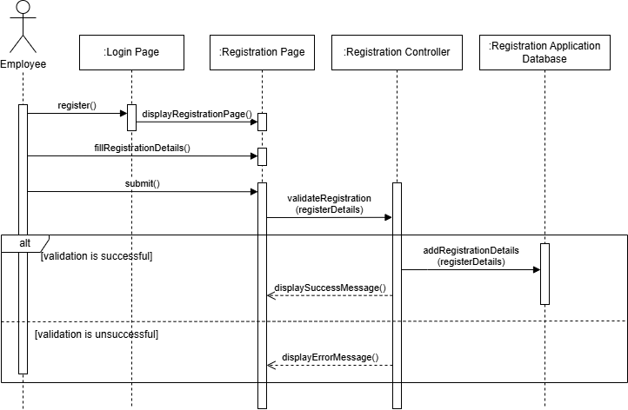
Figure 2.1: Sequence Diagram for Apply Membership
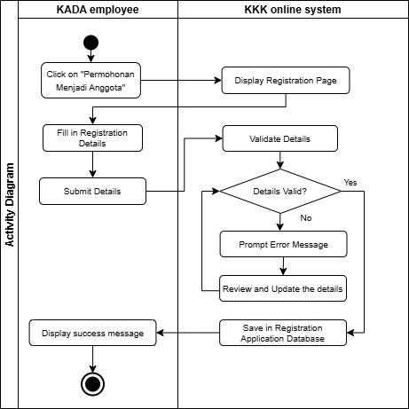
Figure 2.2: Activity Diagram for Apply Membership

US02 User Story Update User Profile
Table 2.2 shows the user story description, followed by the sequence diagram in Figure 2.3 and the activity diagram in Figure 2.4.

Table 2.2: User Story Description for Update User Profile
User story: Update User Profile
ID: US02
User Story Description:
As a registered KKK member
I want to view and verify my personal details
So that I can ensure my information is accurate
Flow of events:
- The employee logs into the KKK system.
- The employee navigates to the "Profil" section.
- The employee reviews the personal and family details for accuracy.
Alternative flow:
If there are errors in the information, the employee clicks “Kemaskini” to update the information and clicks “Simpan” to save the changes.
Acceptance Criteria:
Precondition:
- The employee is logged into the system.
- The employee information is available in the system.
Postcondition:
- The employee has verified or updated their personal details.
Exception flow:
If an error occurs while updating the information, the system prompts the employee to try again later.

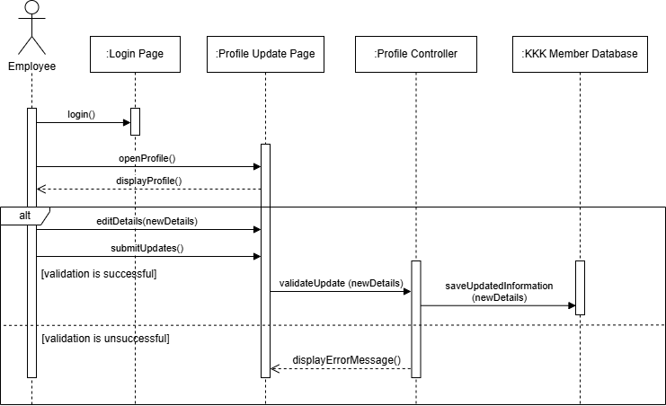
Figure 2.3: Sequence Diagram for Update User Profile
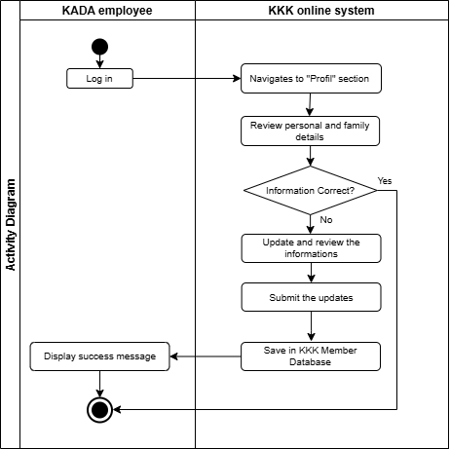
Figure 2.4: Activity Diagram for Update User Profile

US03 User Story View Financial Status
Table 2.3 shows the user story description, followed by the sequence diagram in Figure 2.5 and the activity diagram in Figure 2.6.

Table 2.3: User Story Description for View Financial Status
User story: View Financial Status
ID: US03
User Story Description:
As a registered KKK member
I want to view and verify my financial information
So that I can know about my current financial status
Flow of events:
- The employee logs into the KKK system.
- The employee reviews the financial information displayed on the main page.
Alternative flow: -
Acceptance Criteria:
Precondition:
- The employee is logged into the system.
- The employee information is available in the system.
Postcondition:
- The employee successfully views their current share information.
Exception flow:
The employee successfully views their current financial information.

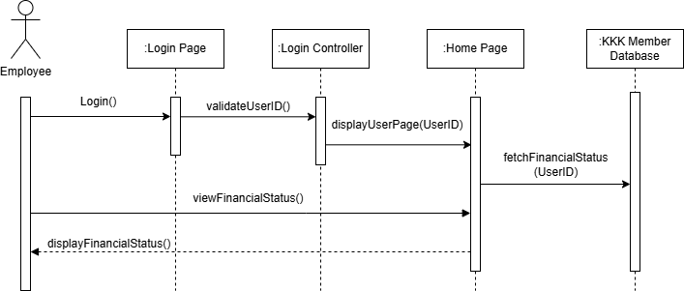
Figure 2.5: Sequence Diagram for View Financial Status

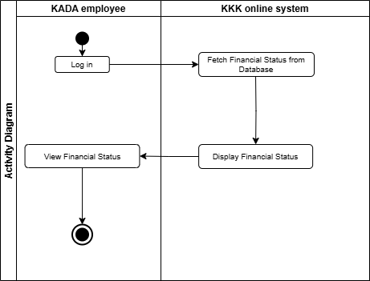
Figure 2.6: Activity Diagram for View Financial Status

US04 User Story Apply for a Loan
Table 2.4 shows the user story description, followed by the sequence diagram in Figure 2.7 and the activity diagram in Figure 2.8.

Table 2.4: User Story Description for Apply for a Loan
User story: Apply for a Loan
ID: US04
User Story Description:
As a KKK Member
I want to apply for a loan through the system
So that I can get financial support
Flow of events:
- The member logs into the system.
- Click "Pinjaman" on the navigation bar.
- Enter the loan amount.
- Fills in all personal details, including name, address and income information.
- Uploads the required documents such as "Butir-Butir Penjamin" and "Borang Pengesahan Majikan".
- Submits the loan application.
- The system confirms the application submission.
Alternative flow:
- If eligibility requirements are not met, the system displays an error message.
- If incomplete details are provided, the system prompts the employee to complete it.
Acceptance Criteria:
Precondition:
- The member is logged into the system.
Postcondition:
- The loan application is saved and processed.
Exception flow: -
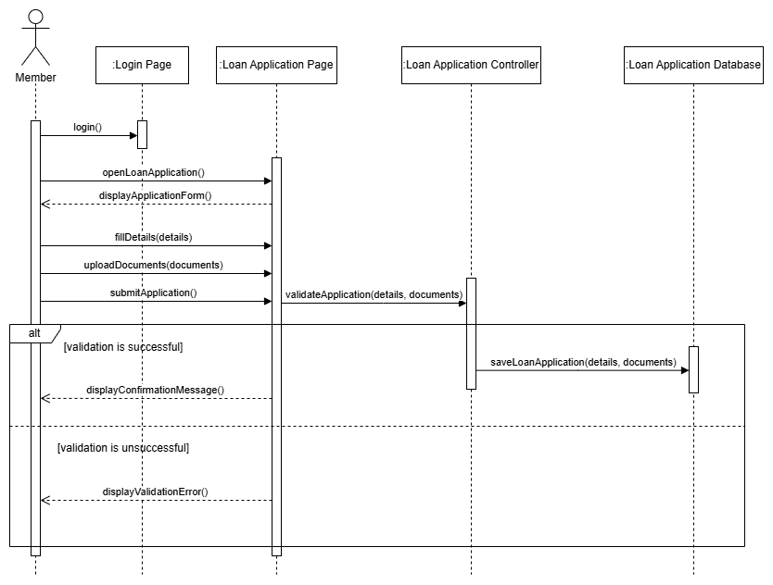
Figure 2.7: Sequence Diagram for Apply for a Loan
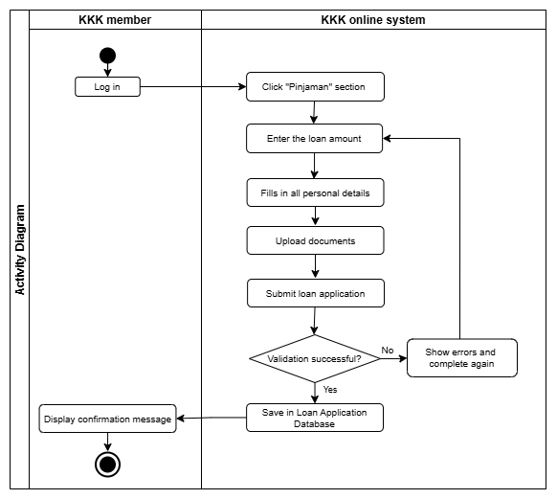
Figure 2.8: Activity Diagram for Apply for a loan

US05 User Story View Loan Application Status
Table 2.5 shows the user story description, followed by the sequence diagram in Figure 2.9 and the activity diagram in Figure 2.10.

Table 2.5: User Story Description for View Loan Application Status
User story: View Loan Application Status
ID: US05
User Story Description:
As a KKK member
I want to check the status of my loan application
So that I know whether it is approved or rejected
Flow of events:
- The system processes the loan application.
- Click the “Pinjaman” section.
- The system displays current loan status, such as “Sedang Diproses”, “Diterima” and “Ditolak”.
- The system displays loan details, including total amount, repayment schedule and outstanding balance.
Alternative flow:
If no active loan exists, the system displays a message stating no current loans.
Acceptance Criteria:
Precondition:
- The employee has submitted a loan application.
Postcondition:
- The employee is able to view the current loan status and details in the system.
Exception flow: -

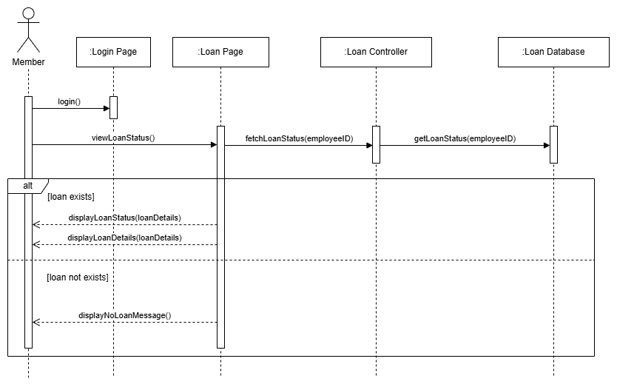
Figure 2.9: Sequence Diagram for View Loan Application Status
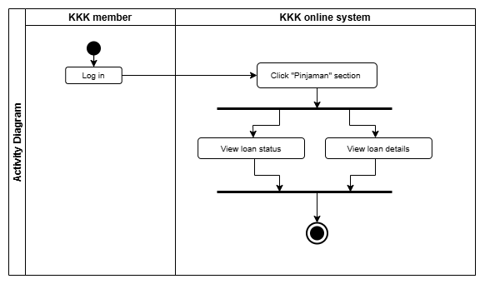
Figure 2.10: Activity Diagram for View Loan Application Status

US06 User Story KKK Admin Login to System
Table 2.6 shows the user story description, followed by the sequence diagram in Figure 2.11 and the activity diagram in Figure 2.12.

Table 2.6: User Story Description for KKK Admin Login to System
User story: KKK Admin Login to System
ID: US06
User Story Description:
As a KKK admin
I want to login to the system
So that I can access the features of the system
Flow of events:
- Admin opens up the KKK web application and is directed to the login page.
- Admin key in user ID and password in their respective column.
- Admin clicks “Log masuk”.
- System validate user ID and password.
Alternative flow:
If invalid user ID and password entered, the system prompts the user to re-enter user ID and password.
Acceptance Criteria:
Precondition:
- Admin has user ID and password.
Postcondition:
- Admin redirected to the Admin main page.
Exception flow: -

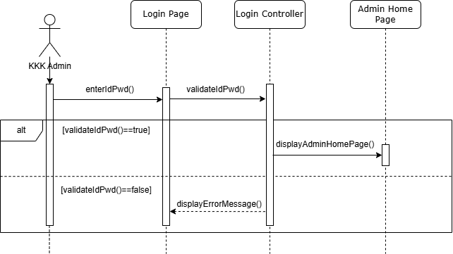
Figure 2.11: Sequence Diagram for KKK Admin Login to System
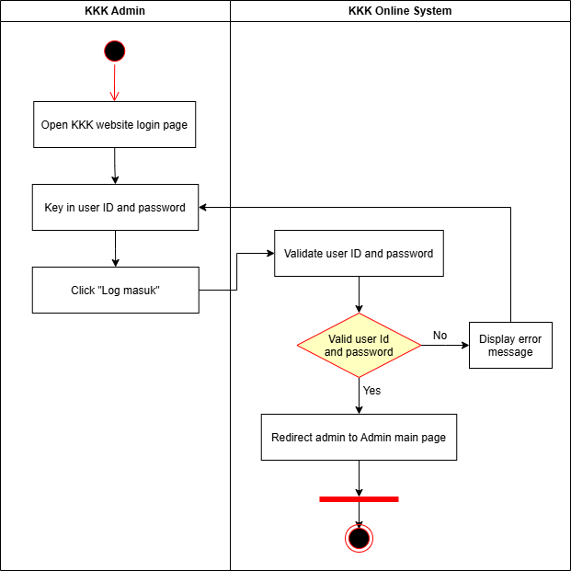
Figure 2.12: Activity Diagram for KKK Admin Login to System

US07 User Story KKK Admin View List
Table 2.7 shows the user story description, followed by the sequence diagram in Figure 2.13 and the activity diagram in Figure 2.14.

Table 2.7: User Story Description for KKK Admin View List
User story: KKK Admin View List
ID: US07
User Story Description:
As a KKK admin
I want to view applicant lists for new member and loan application
So that I can proceed with the approval process
Flow of events:
- Admin navigates the “Permohonan Anggota” tab to view the membership application, “Permohonan Pinjaman” tab to view the loan applications, “Senarai Anggota” tab to view the member lists, and “Senarai Peminjam” to view the loan borrower lists.
- System retrieves information from the database.
Alternative flow: -
Acceptance Criteria:
Precondition:
- Admin logged in to the system.
Exception flow: -

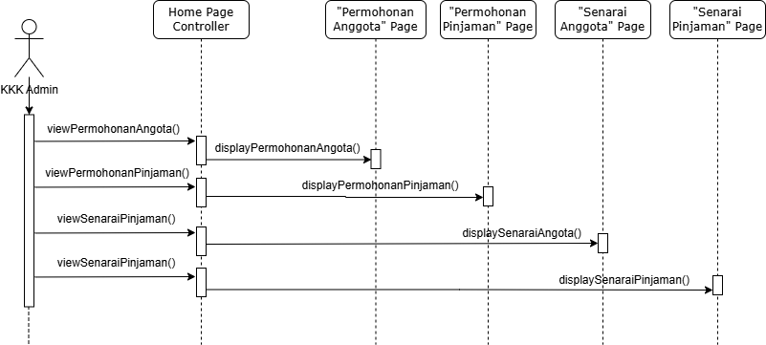
Figure 2.13: Sequence Diagram for KKK Admin View List
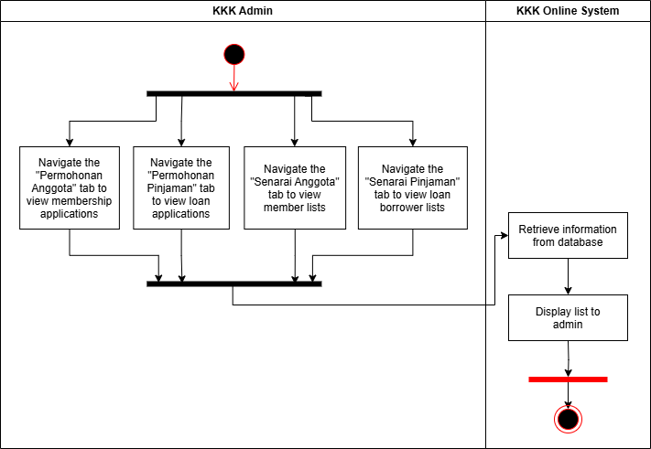
Figure 2.14: Activity Diagram for KKK Admin View List

US08 User Story KKK Admin Approve New Member Application
Table 2.8 shows the user story description, followed by the sequence diagram in Figure 2.17 and the activity diagram in Figure 2.18.

Table 2.8: User Story Description for KKK Admin Approve New Member Application
User story: KKK Admin Approve New Member Application
ID: US08
User Story Description:
As a KKK admin
I want to approve new member applications
So that I can check whether the applicant meets the requirements to become a member of the cooperative
Flow of events:
- Admin navigates to “Permohonan Anggota”.
- Admin clicks “...” to view more about the applications.
- Admin reviews the membership applications.
Alternative flow:
- If approved, the system updates the application status to “Diterima.”
- If rejected, the system updates the application status to “Ditolak.”
Acceptance Criteria:
Precondition:
- Admin logged in to the system.
Postcondition:
- When the membership applications’ status is updated to “Diterima” status, the applicant will be updated to “Senarai Anggota”.
Exception flow: -

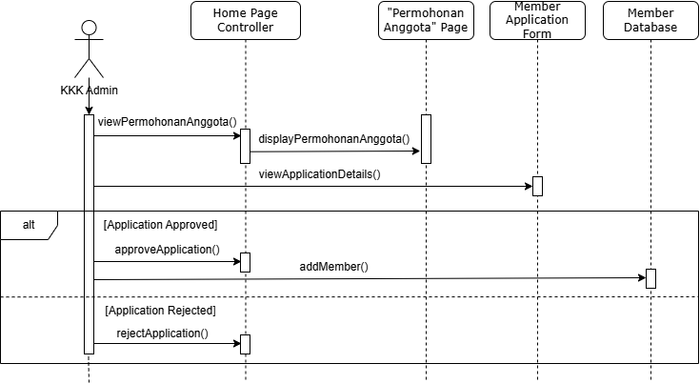
Figure 2.15: Sequence Diagram for KKK Admin Approve New Member Application

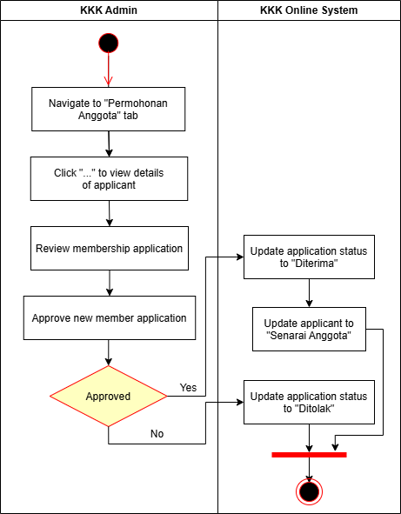
Figure 2.16: Activity Diagram for KKK Admin Approve New Member Application

US09 User Story KKK Admin Approve Loan Application
Table 2.9 shows the user story description, followed by the sequence diagram in Figure 2.17 and the activity diagram in Figure 2.18.

Table 2.9: User Story Description for KKK Admin Approve Loan Application
User story: KKK Admin Approve Loan Application
ID: US09
User Story Description:
As a KKK admin
I want to approve loan applications
So that I can check whether the applicant meets the requirements to make a loan
Flow of events:
- Admin navigates to “Permohonan Pinjaman”.
- Admin clicks “...” to view more about the applications.
- Admin reviews the loan applications.
Alternative flow:
- If approved, the system updates the application status to “Diterima.”
- If rejected, the system updates the application status to “Ditolak.”
Acceptance Criteria:
Precondition:
- Admin logged in to the system.
Postcondition:
- When the loan applications’ status is updated to “Diterima” status, the application will be updated to “Senarai Pinjaman”.
Exception flow: -

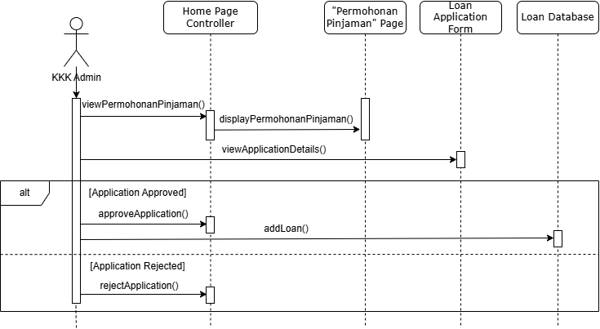
Figure 2.17: Sequence Diagram for KKK Admin Approve Loan Application
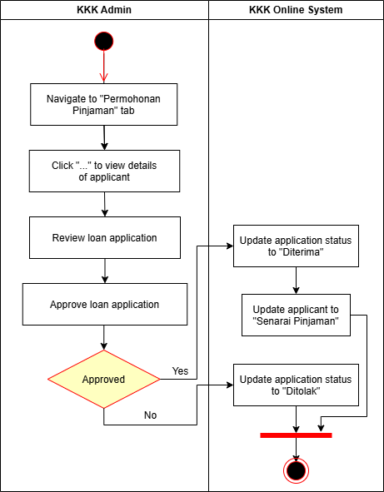
Figure 2.18: Activity Diagram for KKK Admin Approve Loan Application

US10 User Story KKK Admin Generate Reports
Table 2.10 shows the user story description, followed by the sequence diagram in Figure 2.19 and the activity diagram in Figure 2.20.

Table 2.10: User Story Description for KKK Admin Generate Reports
User story: KKK Admin Generate Reports
ID: US10
User Story Description:
As a KKK admin
I want to generate reports
So that future decisions can be made for the cooperative
Flow of events:
- Admin navigates to the “Laporan” tab.
- Admin selects the report type, either monthly or annual and specifies the time frame.
- System retrieves relevant data from the database, including new member applications, loan applications, fees claimed and contributions claimed.
- System generates a financial summary and detailed breakdown of each category for the specified period.
- System displays the report, providing options to view in detail, export or print the report.
Alternative flow:
If invalid time frame is selected, the system prompts the user to select the correct time frame.
Acceptance Criteria:
Precondition:
- Admin logged in to the system.
Exception flow: -

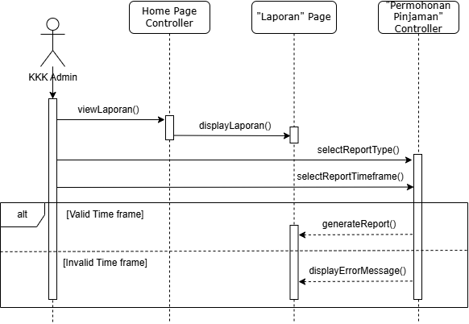
Figure 2.19: Sequence Diagram for KKK Admin Generate Reports
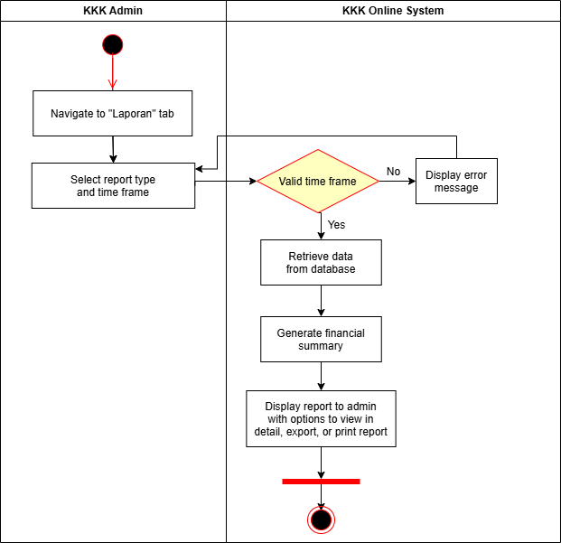
Figure 2.20: Activity Diagram for KKK Admin Generate Reports

US11 User Story KKK Admin Record Transactions
Table 2.11 shows the user story description, followed by the sequence diagram in Figure 2.21 and the activity diagram in Figure 2.22.

Table 2.11: User Story Description for KKK Admin Record Transactions
User story: KKK Admin Record Transactions
ID: US11
User Story Description:
As a KKK admin
I want to record transactions made by members
So that transactions can be reflected in the member profile
Flow of events:
- Admin navigates to the Record Transaction tab.
- The system displays the list of members.
- Admin searches and selects the member to be updated.
- The system displays the financial status of the member.
- Admin enters the amount to be added or subtracted.
- The system prompts a confirmation message.
- Admin clicks “Ok”.
- The system updates the database and the transaction is recorded.
Alternative flow:
If “OK” is not selected, the system will not update the database.
Acceptance Criteria:
Precondition:
- Admin logged in to the system.
Exception flow: -

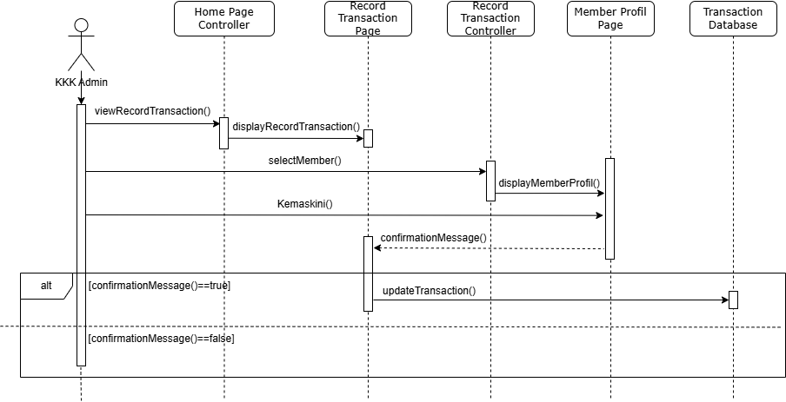
Figure 2.21: Activity Diagram for KKK Admin Record Transactions

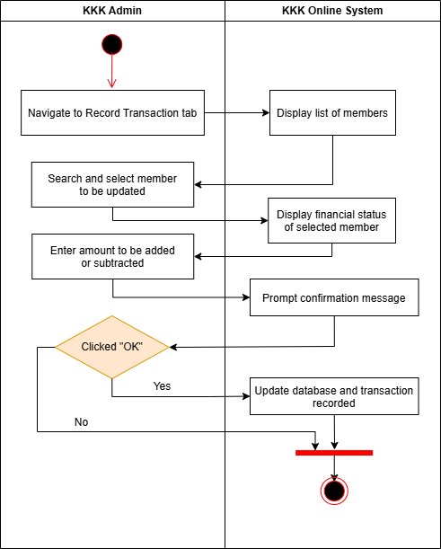
Figure 2.22: Activity Diagram for KKK Admin Record Transactions

US12 User Story KKK Admin Update Policies
Table 2.12 shows the user story description, followed by the sequence diagram in Figure 2.23 and the activity diagram in Figure 2.24.

Table 2.12: User Story Description for KKK Admin Update Policies
User story: KKK Admin Update Policies
ID: US12
User Story Description:
As a KKK admin
I want to update policies
So that the cooperative business rules such as minimum share capital requirements for loan application and the loan interest rate can be known by members
Flow of events:
- Admin navigates to “Kemaskini Polisi”.
- System displays all policies.
- Admin clicks “Kemaskini” to update the relevant section.
- Admin updates the new values.
- Admin clicks “Simpan”.
- The system prompts a confirmation message.
- The admin clicks “Ok”.
- The system updates the database and the policies are updated.
Alternative flow:
If “OK” is not selected, the system will not update the database.
Acceptance Criteria:
Precondition:
- Admin logged in to the system.
Exception flow: -

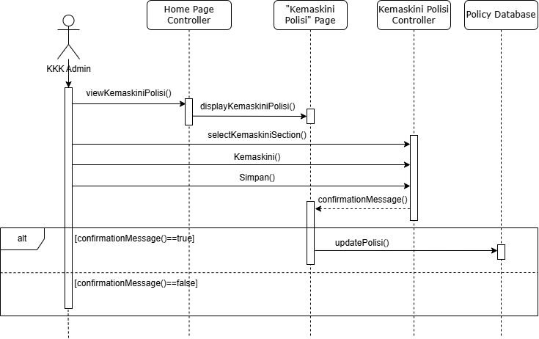
Figure 2.23: Sequence Diagram for KKK Admin Update Policies
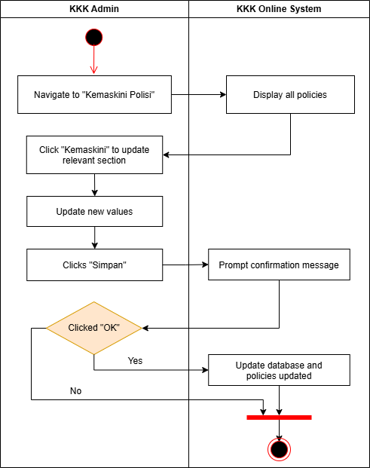
Figure 2.24: Activity Diagram for KKK Admin Update Policies

US13 User Story KKK Admin Update Banners
Table 2.13 shows the user story description, followed by the sequence diagram in Figure 2.25 and the activity diagram in Figure 2.26.

Table 2.13: User Story Description for KKK Admin Update Banners
User story: KKK Admin Update Banners
ID: US13
User Story Description:
As a KKK admin
I want to update banners on the system
So that members will know the announcement form the cooperative
Flow of events:
- Admin navigates to “Kemaskini Iklan”.
- Admin uploads a new photo.
- Admin clicks “Kemaskini”.
- System prompts a confirmation message.
- The admin clicks “Ok”.
- The system updates the database and the banners are updated.
Alternative flow:
If “OK” is not selected, the system will not update the database.
Acceptance Criteria:
Precondition:
- Admin logged in to the system.
Exception flow: -

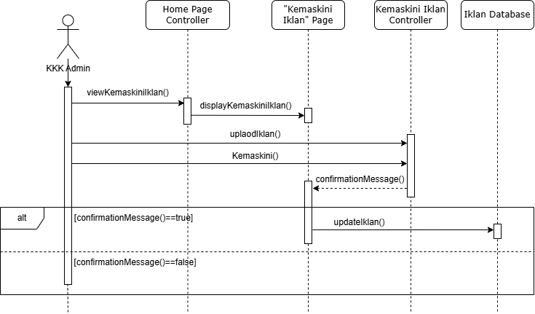
Figure 2.25: Sequence Diagram for KKK Admin Update Banners

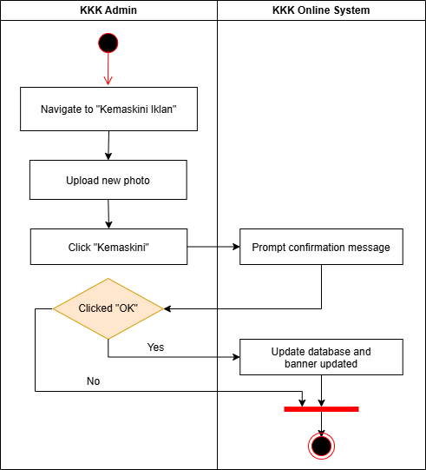
Figure 2.26: Activity Diagram for KKK Admin Update Banners

Performance and Other Requirements
This section defines the way systems behave or operate, separated from functional requirements. The characteristics and quality attributes are specified such as usability, reliability, performance, security, maintainability, and compatibility.

Software System Attributes
Software system attributes specify the overall qualities or characteristics that are expected to achieve in the system. These attributes are the foundation of the KKK Online System, as stated below:

- Acceptability: System must be compatible with different operating systems such as Windows, macOS, Linux, and mobile devices like iOS and Android. System must be adaptable with all device types, including workstations, laptops, tablets and smartphones.
- Correctness: The system must fully meet its requirements specifications, with any deviation from the requirements considered as incorrect.
- Reliability: Systems should be reliable, failures should be minimised and issues that could lead to software failure should be addressed.
- Usability: System should be easy to use, be learnable to beginners, convenient, and effective in handling errors.

Performance
This section defines the software system response time of user actions under a certain workload, throughput and resource usage.

- System shall be able to maintain 99.9% uptime, making it always available for corporate users. Service interruption or temporal shut down such as maintenance or update should be minimised or communicated beforehand.
- System response time should be at most 1 seconds under normal loads.
- System should be able to support at least 100 active user sessions at the same time and multiple user sessions should not slow down response time.
- The system must retrieve member data within 1 second of a search query under normal load with up to 50 concurrent queries.

Other Requirements
Localisation Requirements
- The system is used exclusively for the KKK, and the cooperative is in Malaysia.
- Languages supported: Malay only.
- Date formats: DD/MM/YYYY
- Time zone adjustment: UTC+8
- Currency: Ringgit Malaysia (RM)

Data Migration Requirements
The KKK Online System is replacing the existing manual system. Thus, an interface is required for the admin to add existing data to the new system.

Design Constraints
This section describes the design constraints of the system, which includes security constraints, safety constraints and the business rules that must be adhered to.

Security constraints
This section states the requirements regarding any security or privacy concerns surrounding use of the system and protection of the data used or collected. User identity authentication requirements are defined.

- The system must have an automated data backup and recovery mechanism to prevent data lost. Regular backup should be scheduled and backup data are stored in a secure, offsite location.
- Passwords of all users of the system must have a bit strength of at least 64 bit, that is at least 6 characters long and includes a mix of uppercase and lowercase letters, numbers, and special symbols.
- Wireless communication throughout the system will be encrypted using TLS 1.3 at the application layer and WPA2-Enterprise at the data link layer.
- The system shall provide two level of access:
- An administrator level for unrestricted access to all system functionality.
- A member layer for access to member functionality only.

Safety constraints
This section specifies the requirements that are concerned with possible loss, damage or harm that could result from the usage of the system.
- System should ensure all personal and financial data collected during membership registration or loan applications is protected against unauthorised access by the General Data Protection Regulation (GDPR) and ISO/IEC 27001 standards.
- All activities should be logged and able to retrace back, to provision recovery from system failure All logs must be protected against unauthorised changes, and can only be accessed by authorised personnel for maintenance purposes.
- The system must be capable of restoring itself to the nearest previous state if an error occurs, for example system crash or a connectivity loss.

Business Rule
This section defines the policies and constraints the system must adhere to, and functions specific to roles that aligns with the organisational practices.

- Only the admin can modify loan repayment terms and policies.
- Accessing member personal information is limited to admin authority. System should restrict access to member data by non admin role, except every member is able to view and modify their own personal data.

